2000031668

K Lohith SEC-13

Skill 8

Get details by employee email

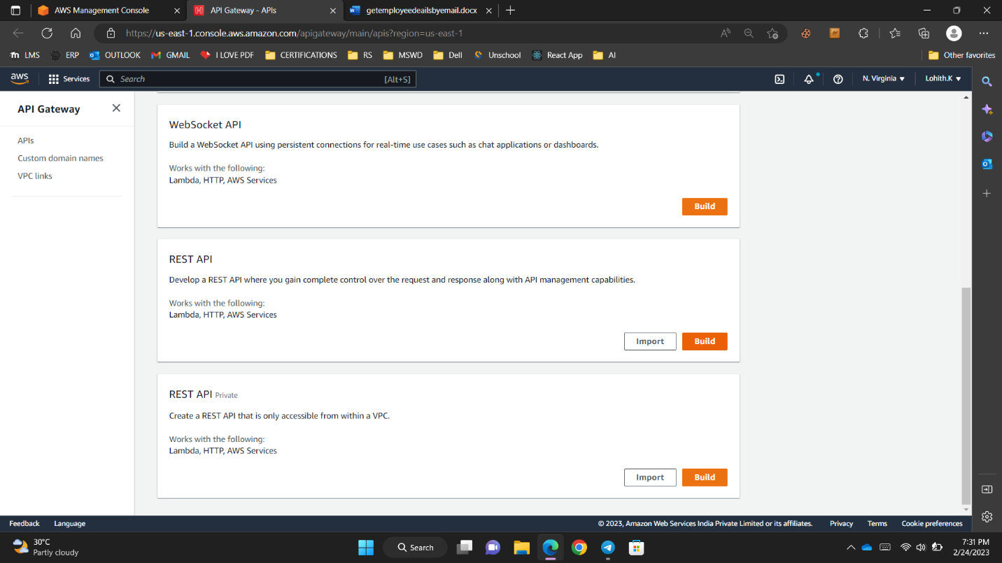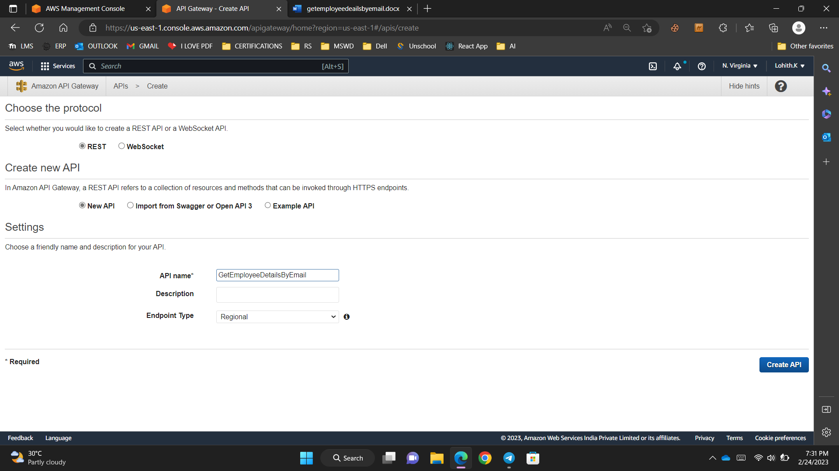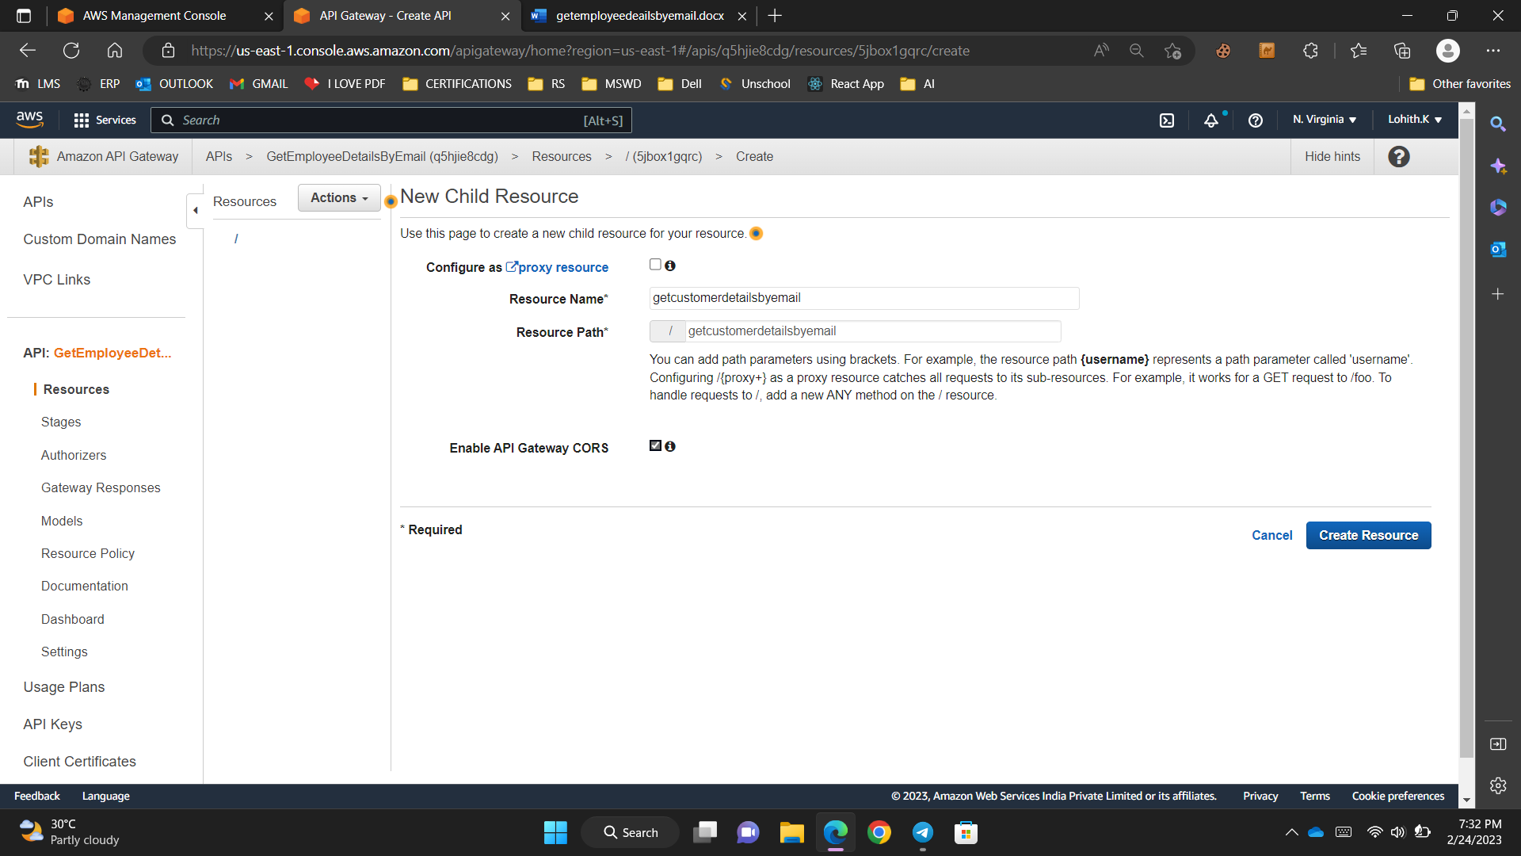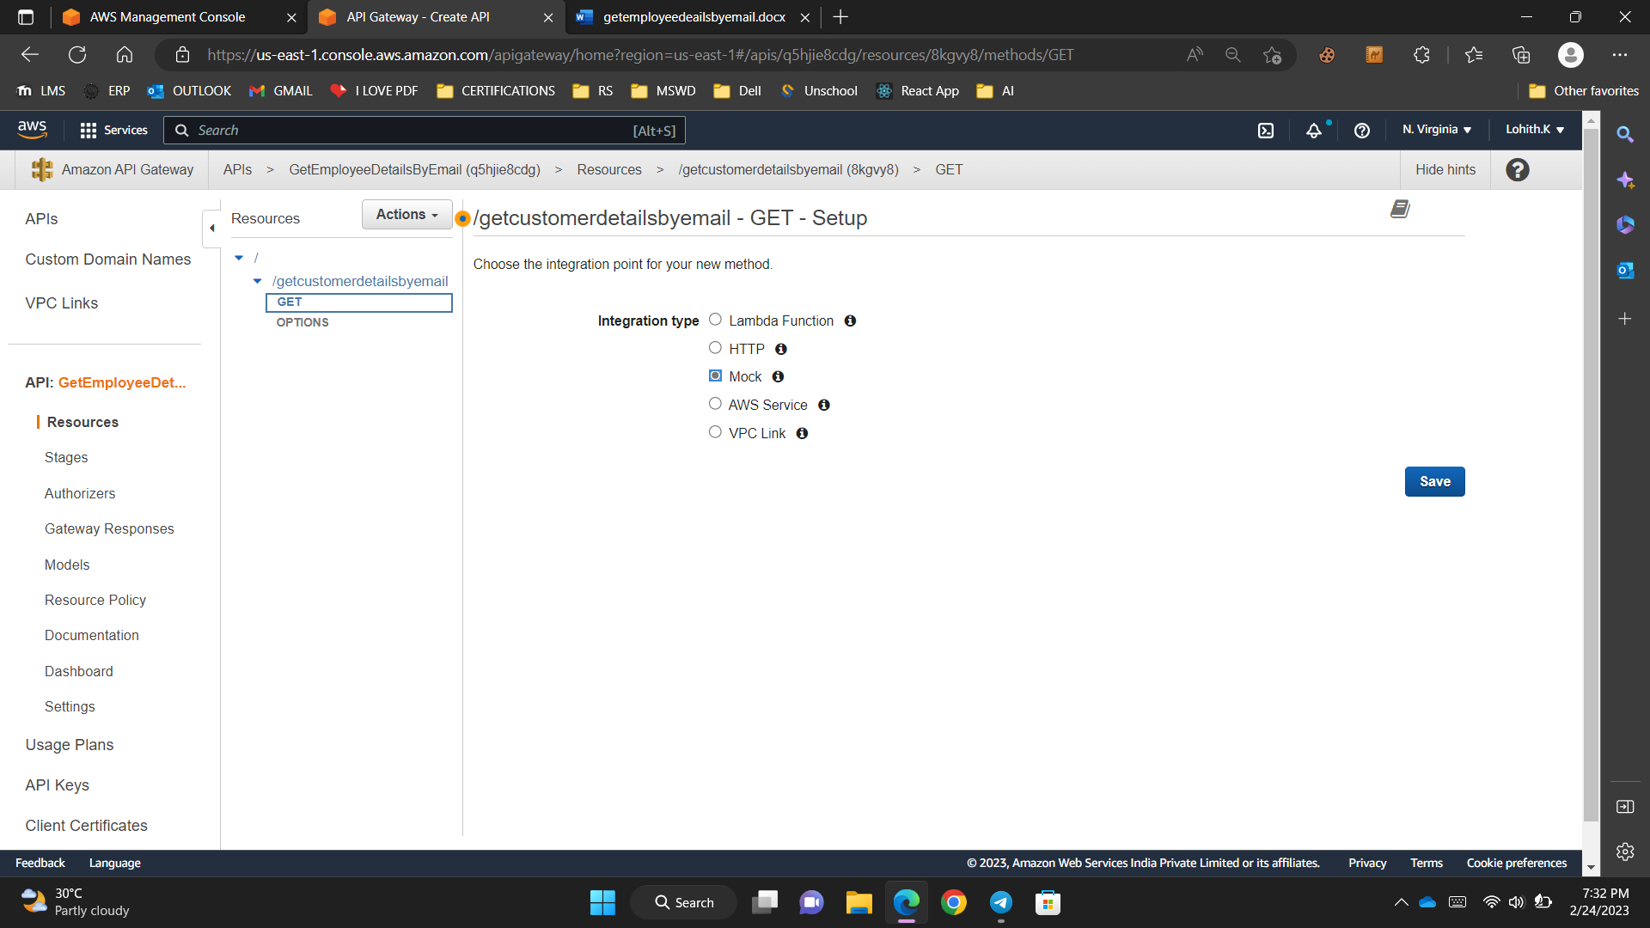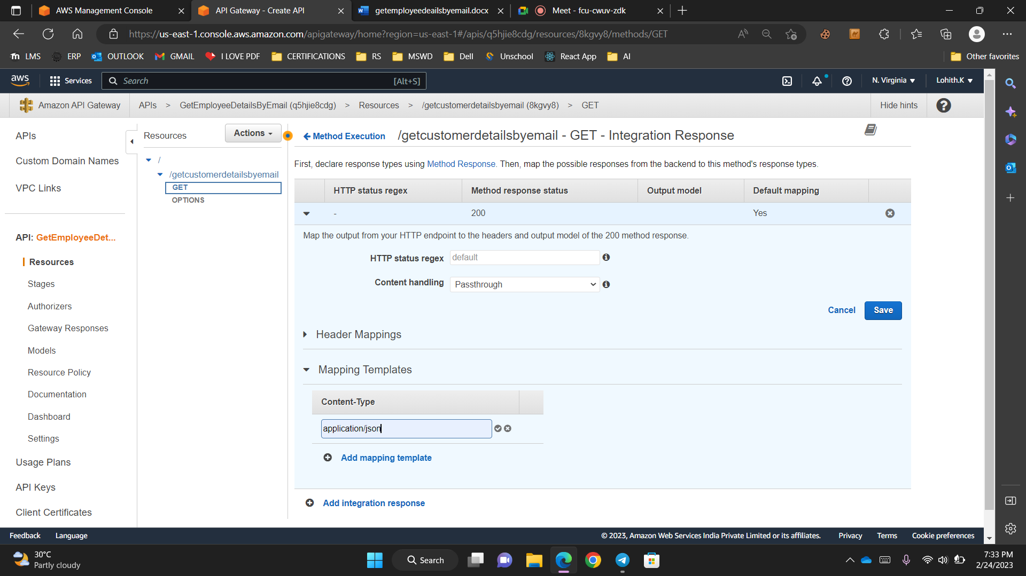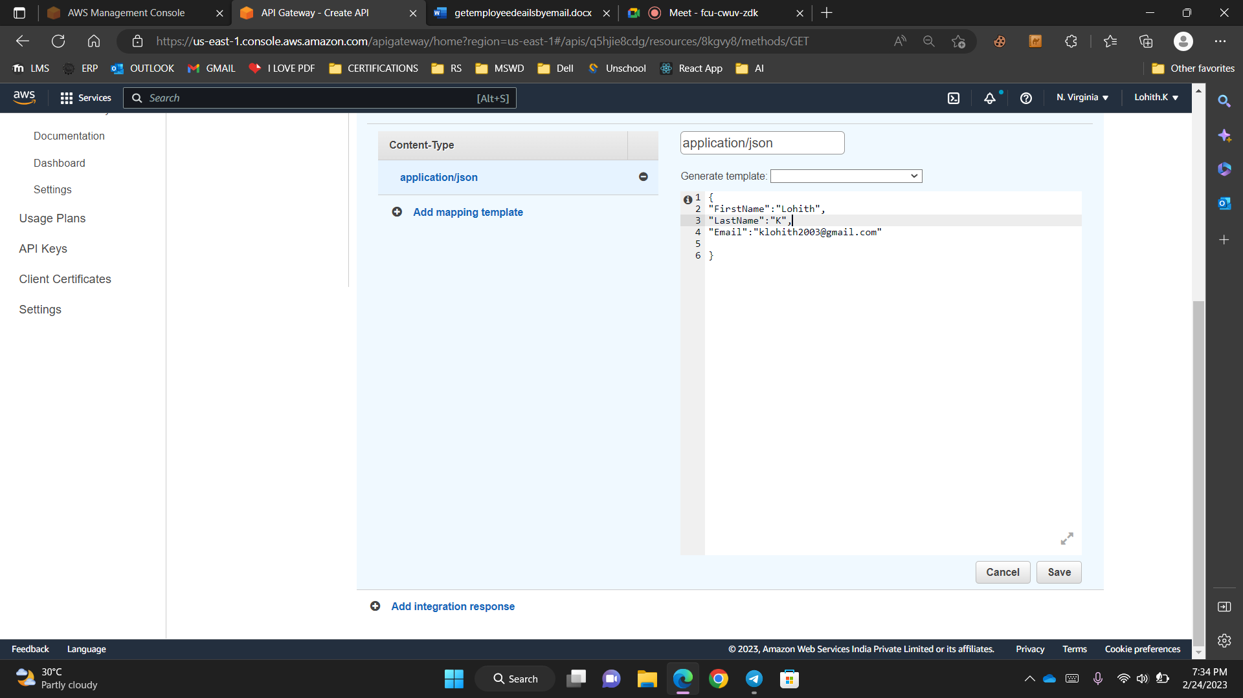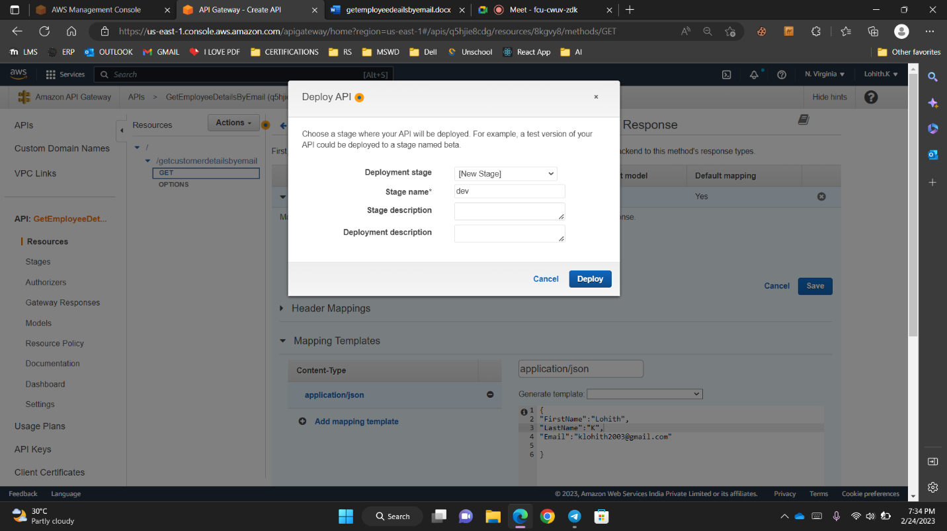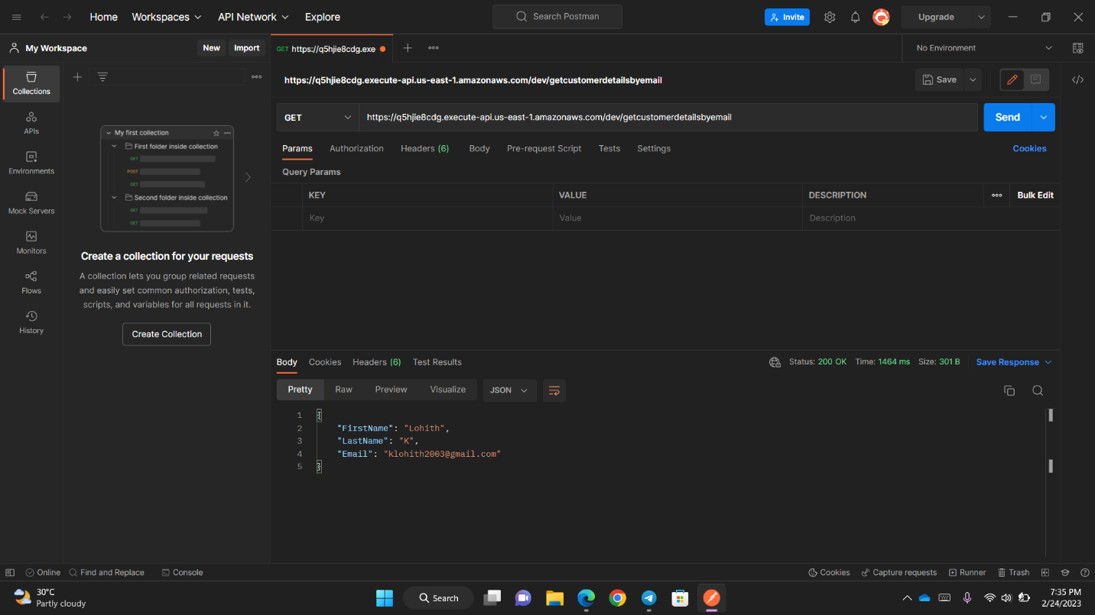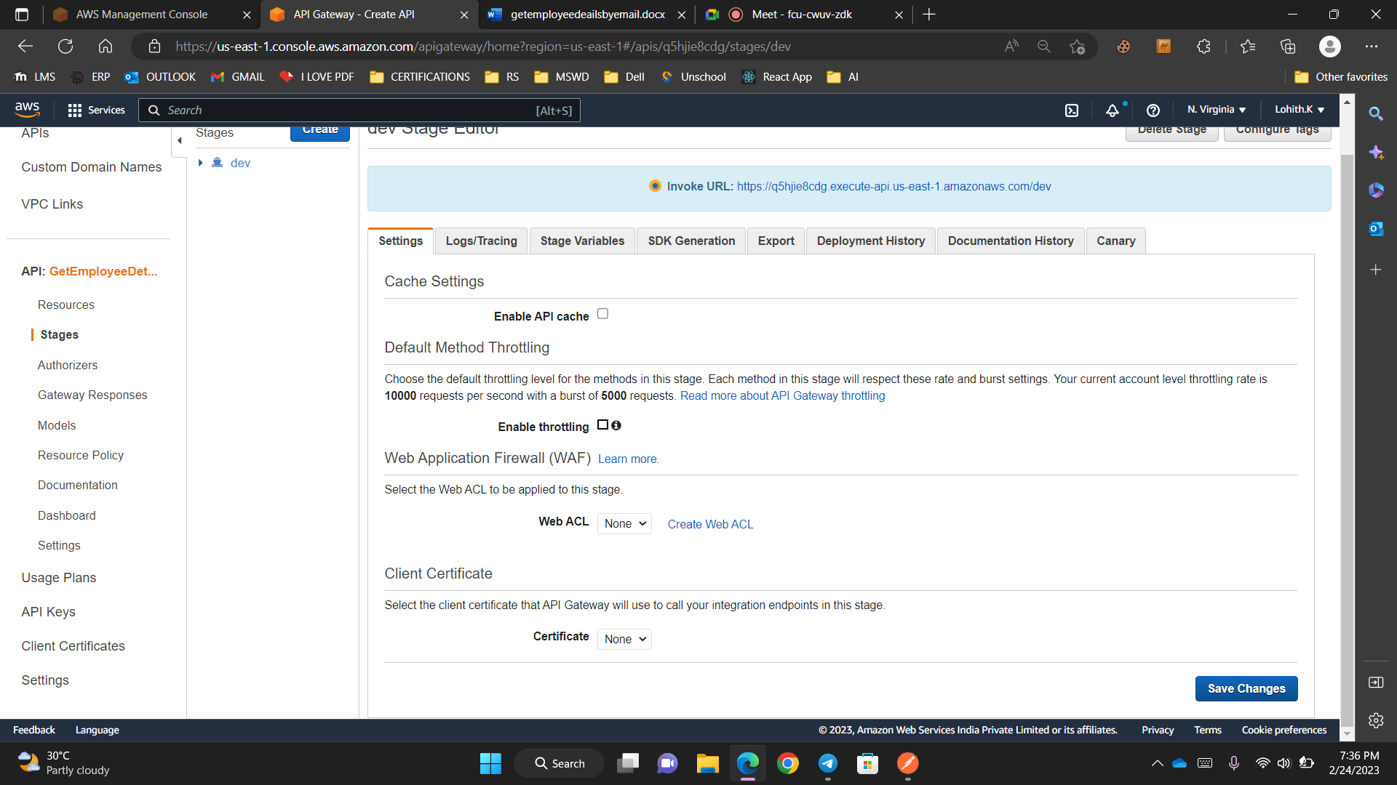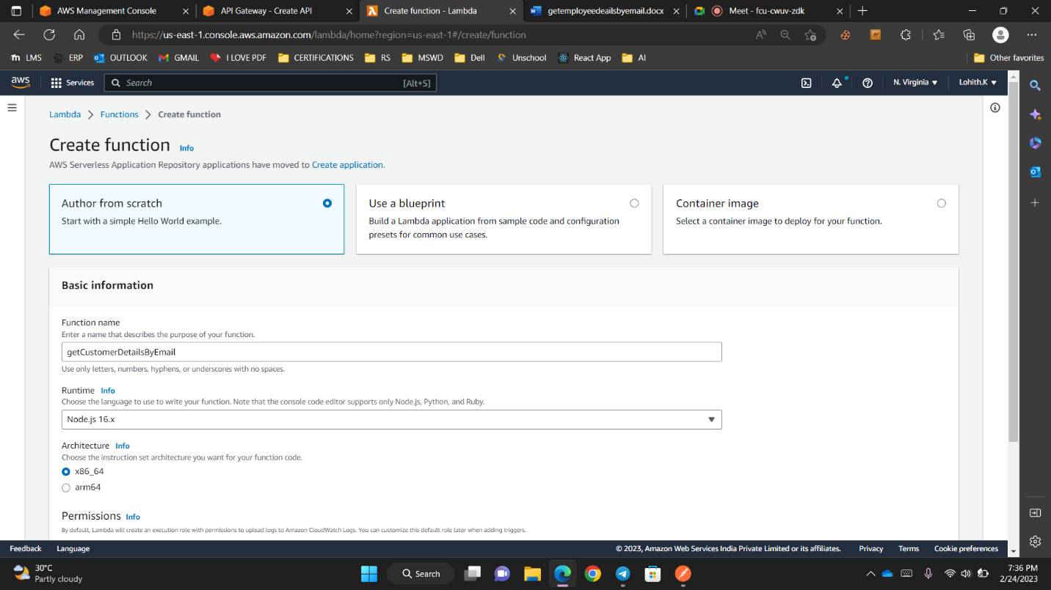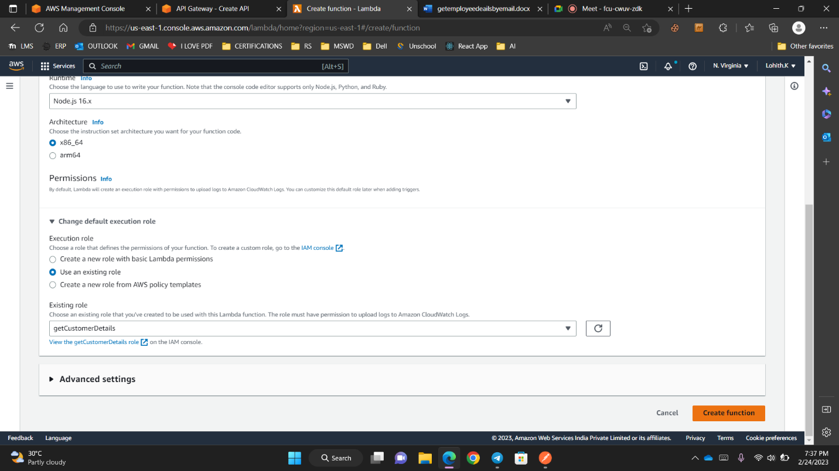

const AWS = require('aws-sdk');

var docClient = new AWS.DynamoDB.DocumentClient();

var tableName = "CustomerDetails";

exports.handler = (event, context, callback) => {

console.log(event.EmailID)

var params = {

TableName : tableName,

Key:{

"EmailID" : event.EmailID

}

}

docClient.get(params, function(err,data){

callback(err, data);

})

};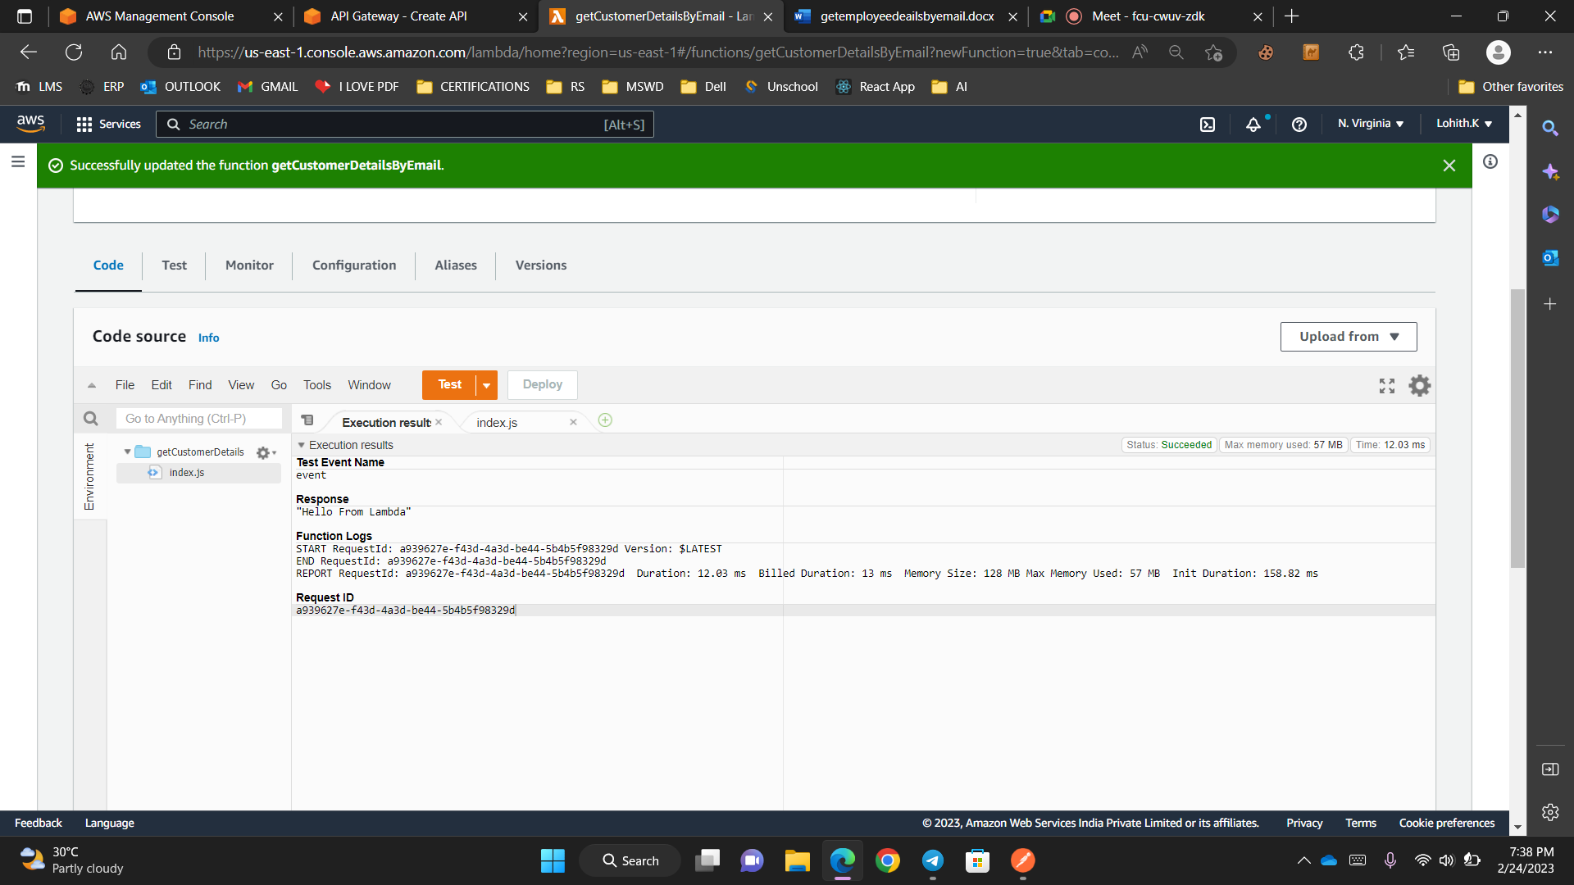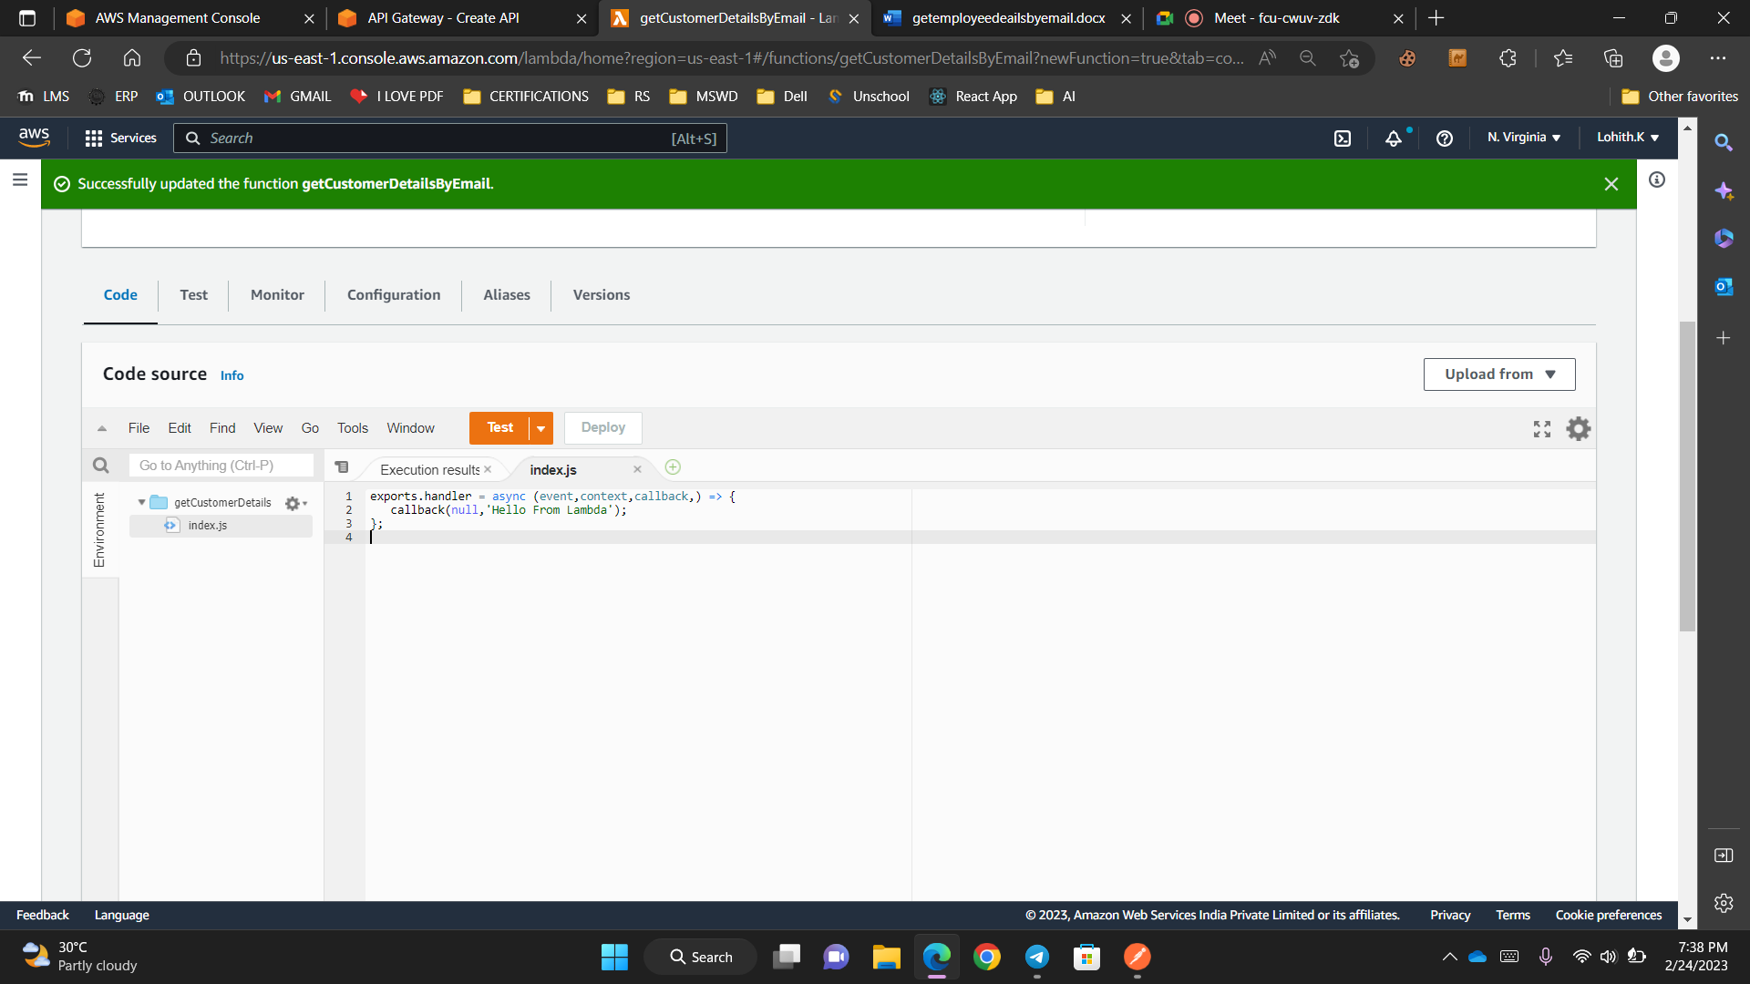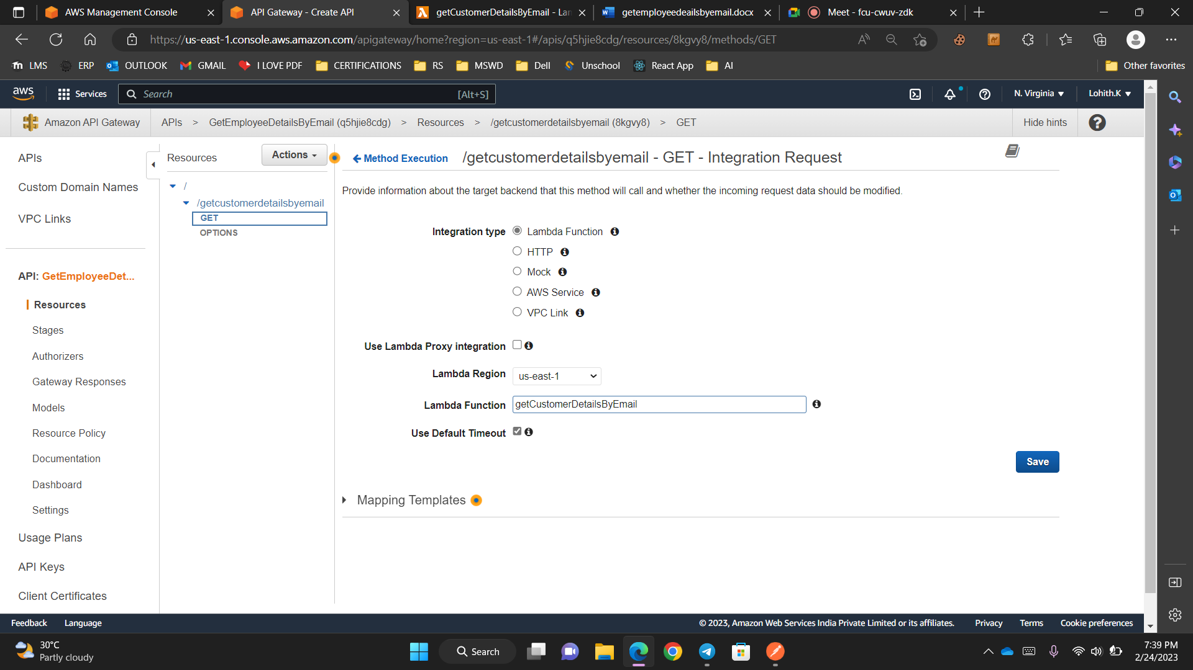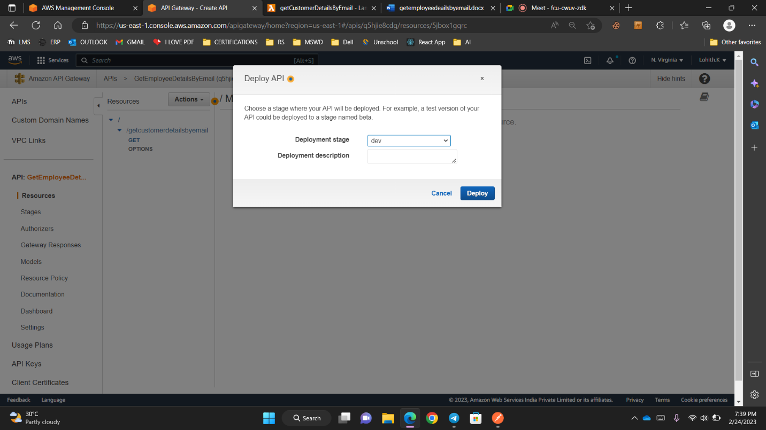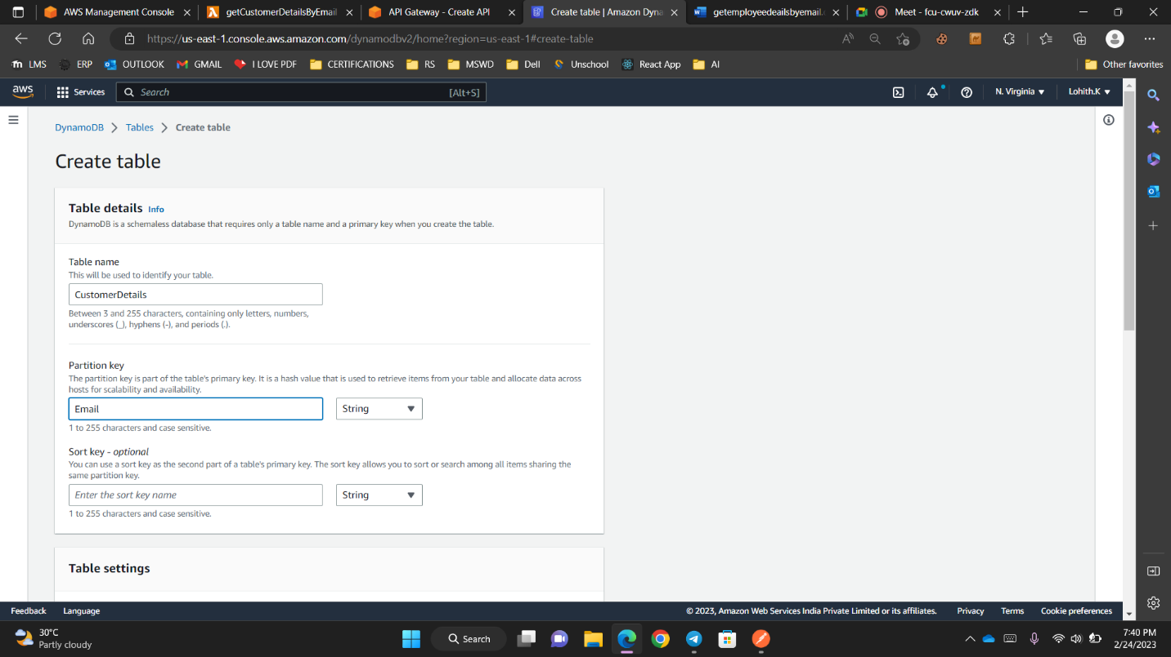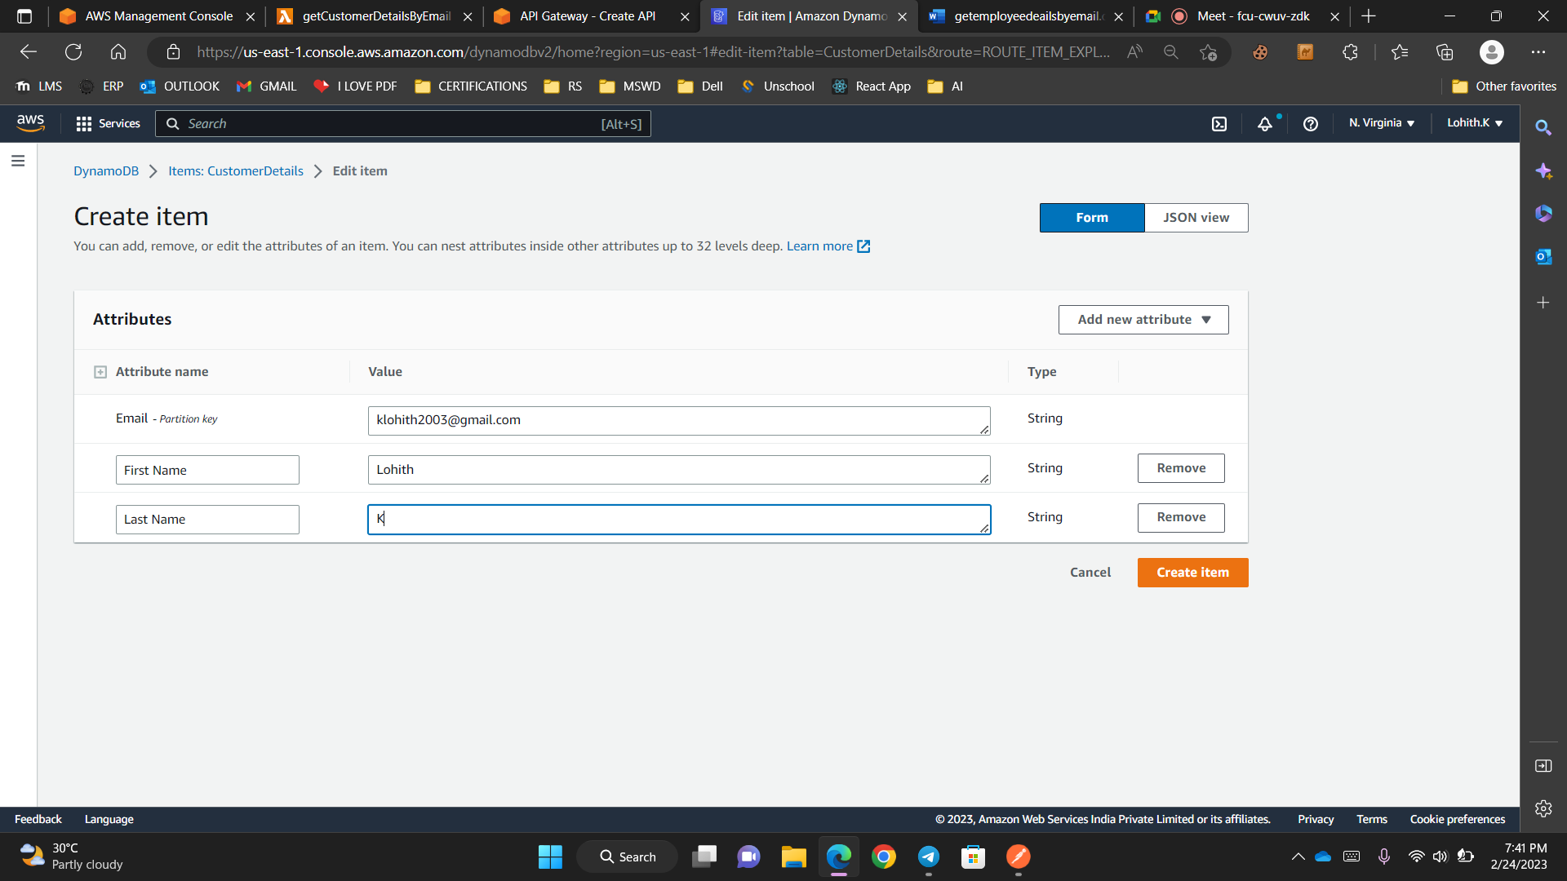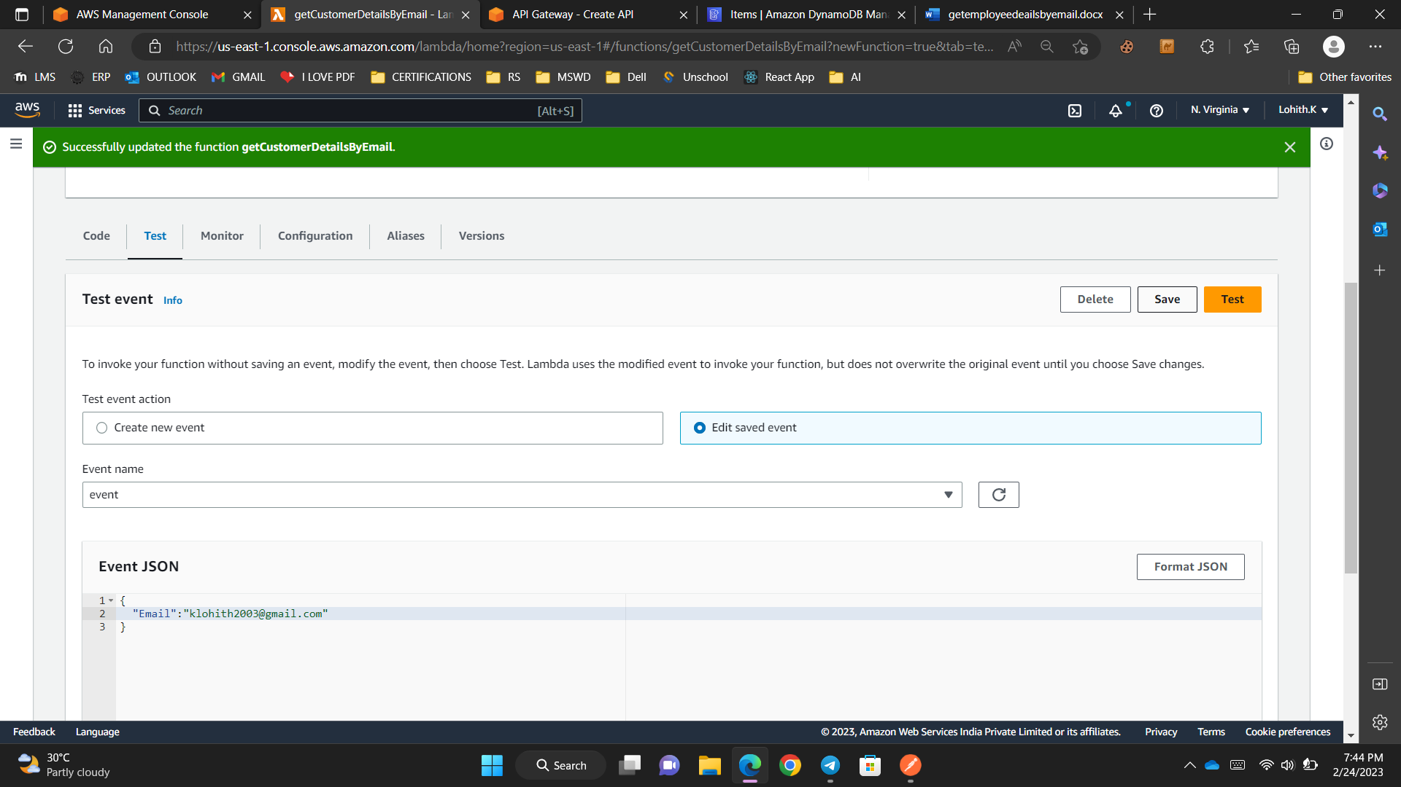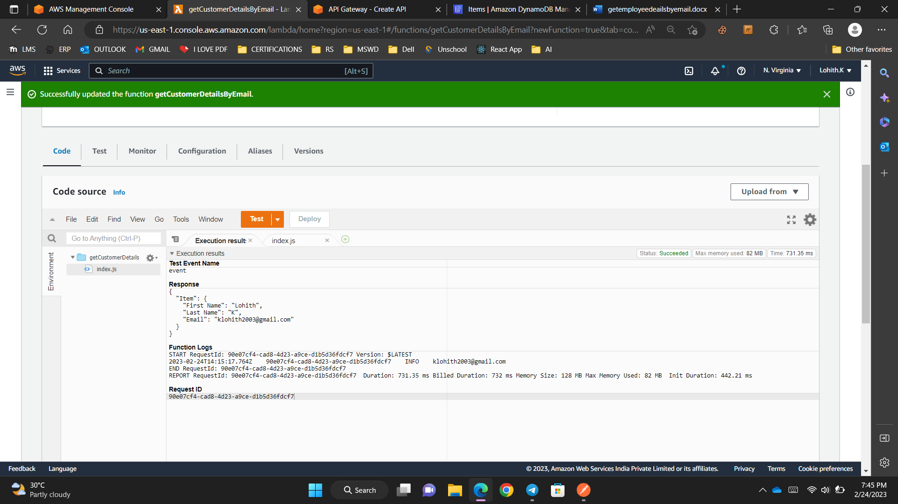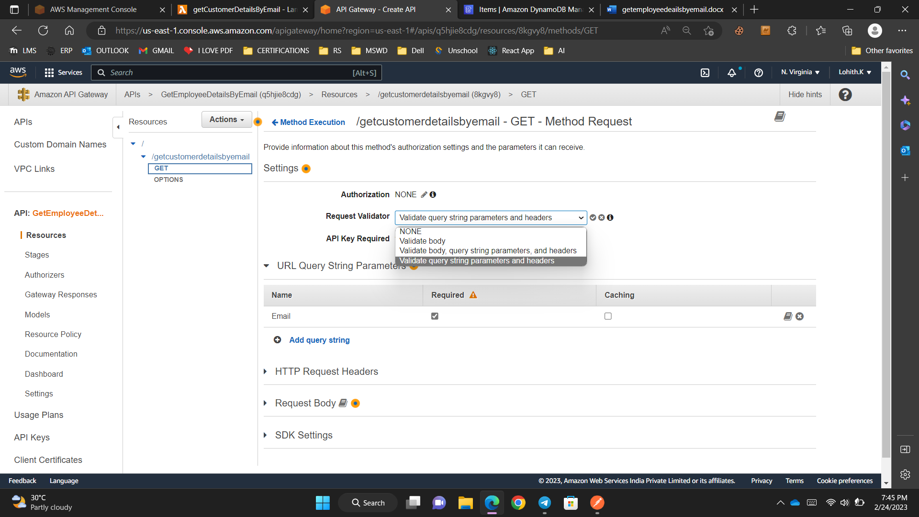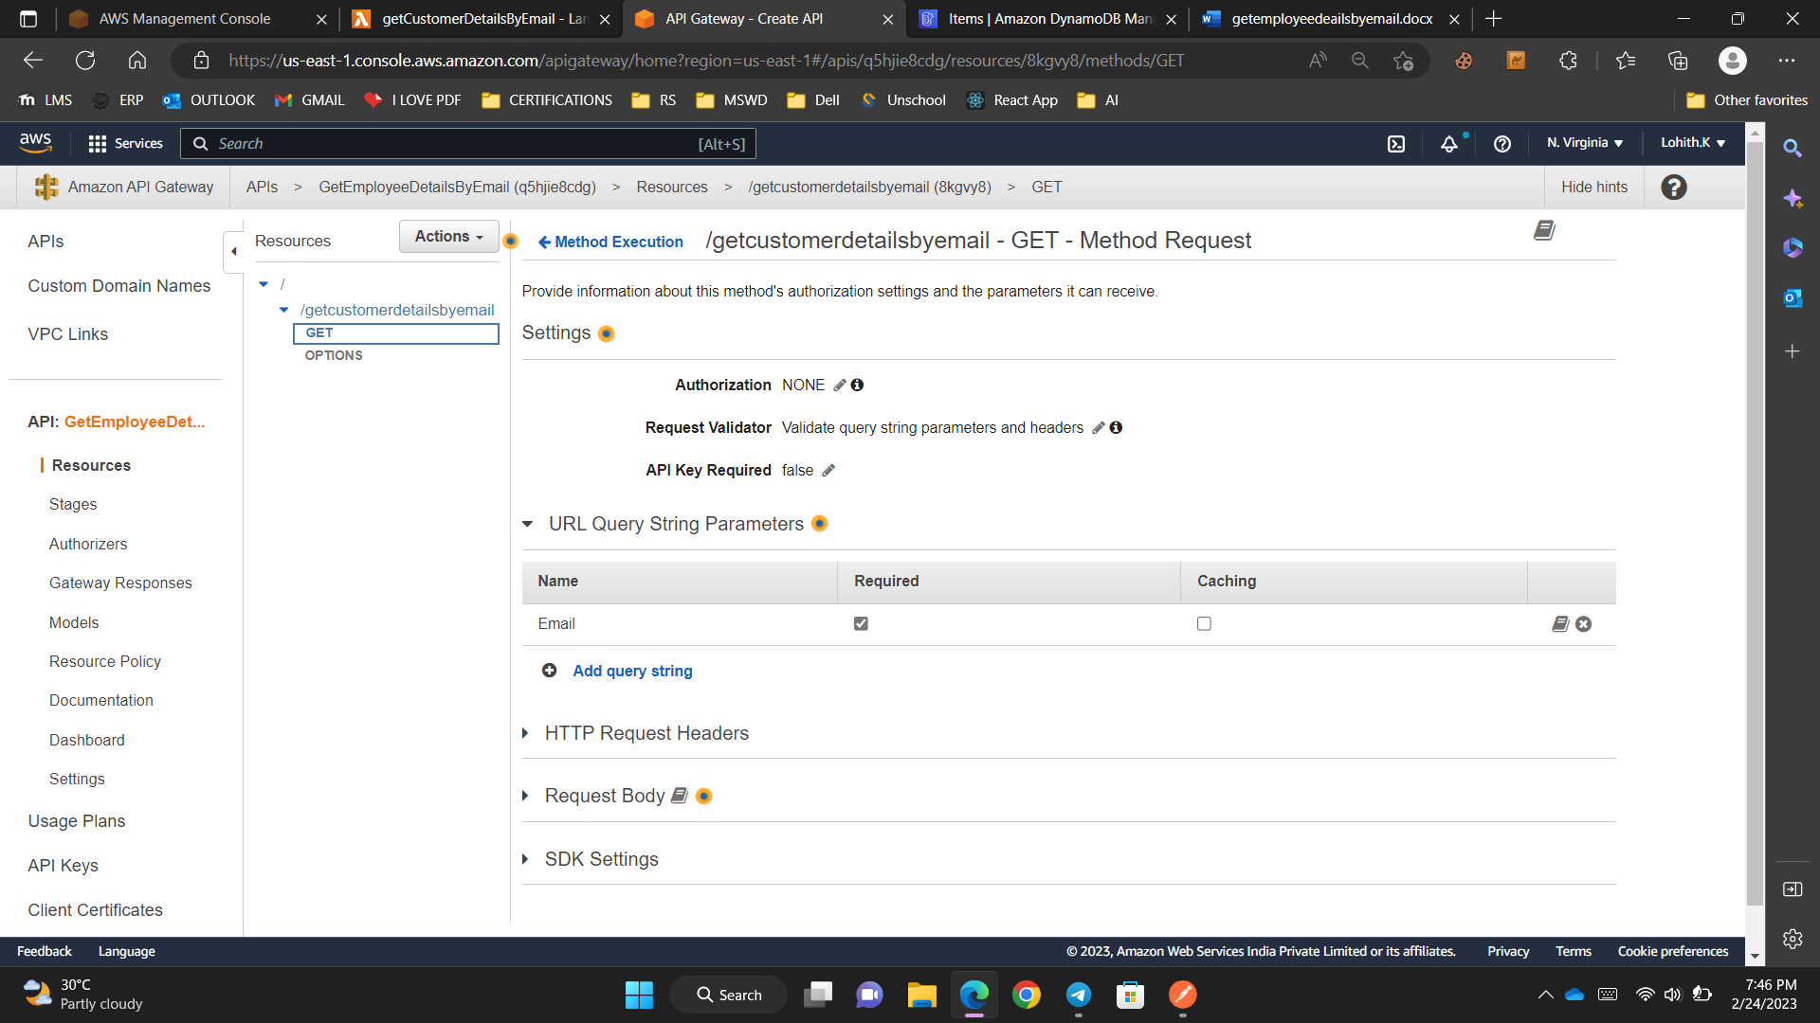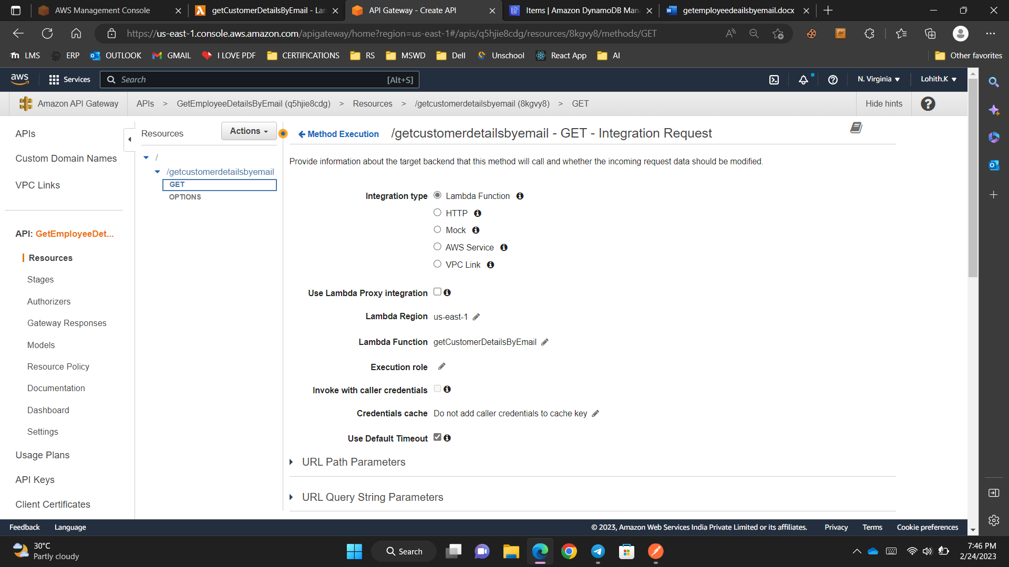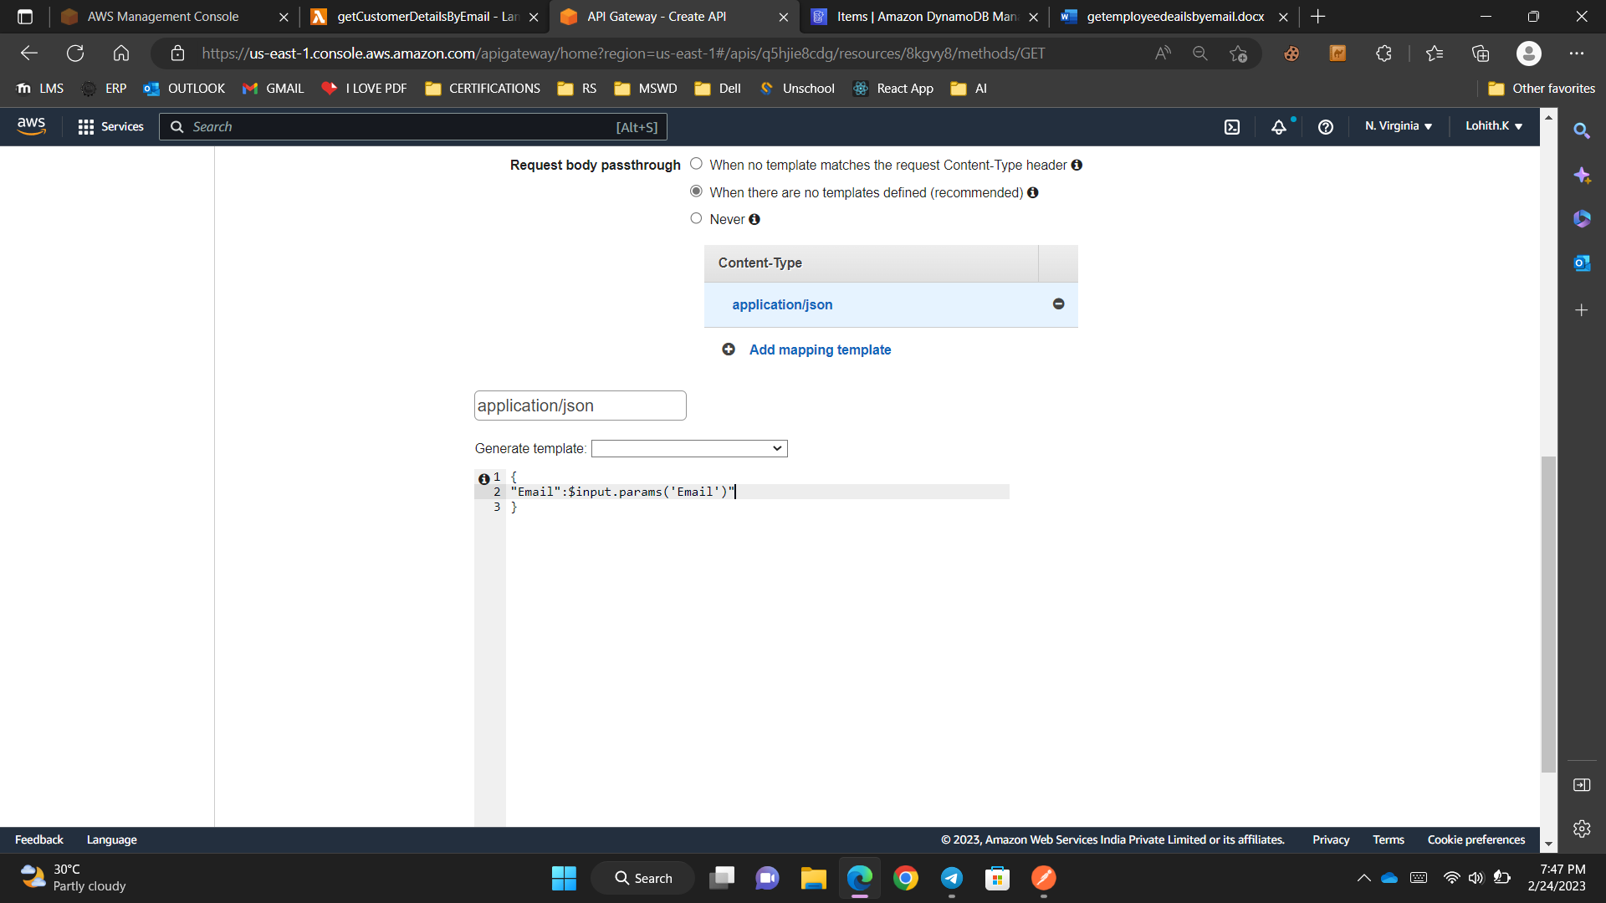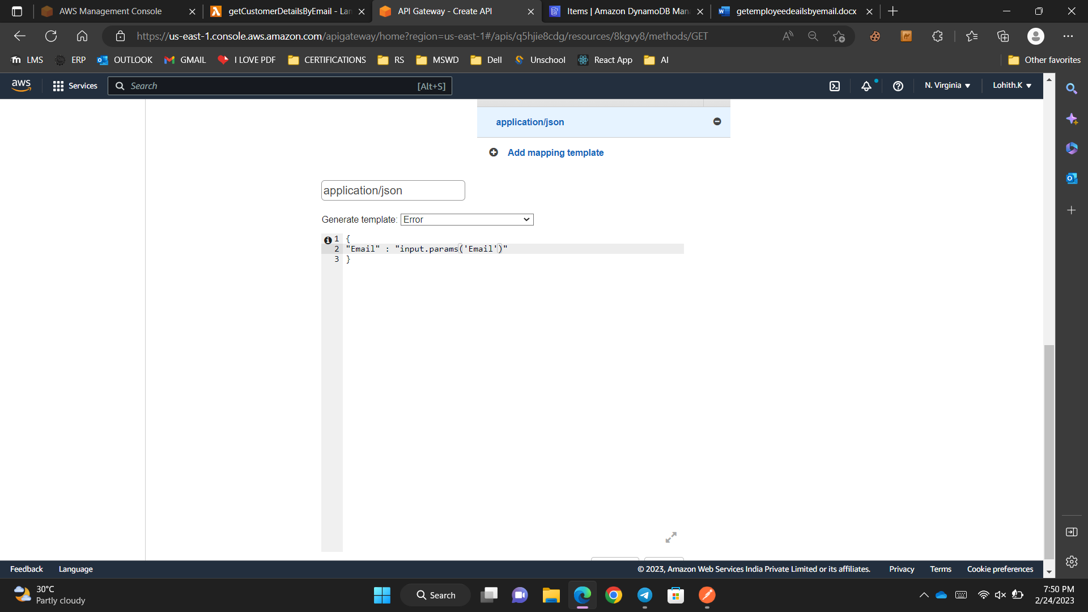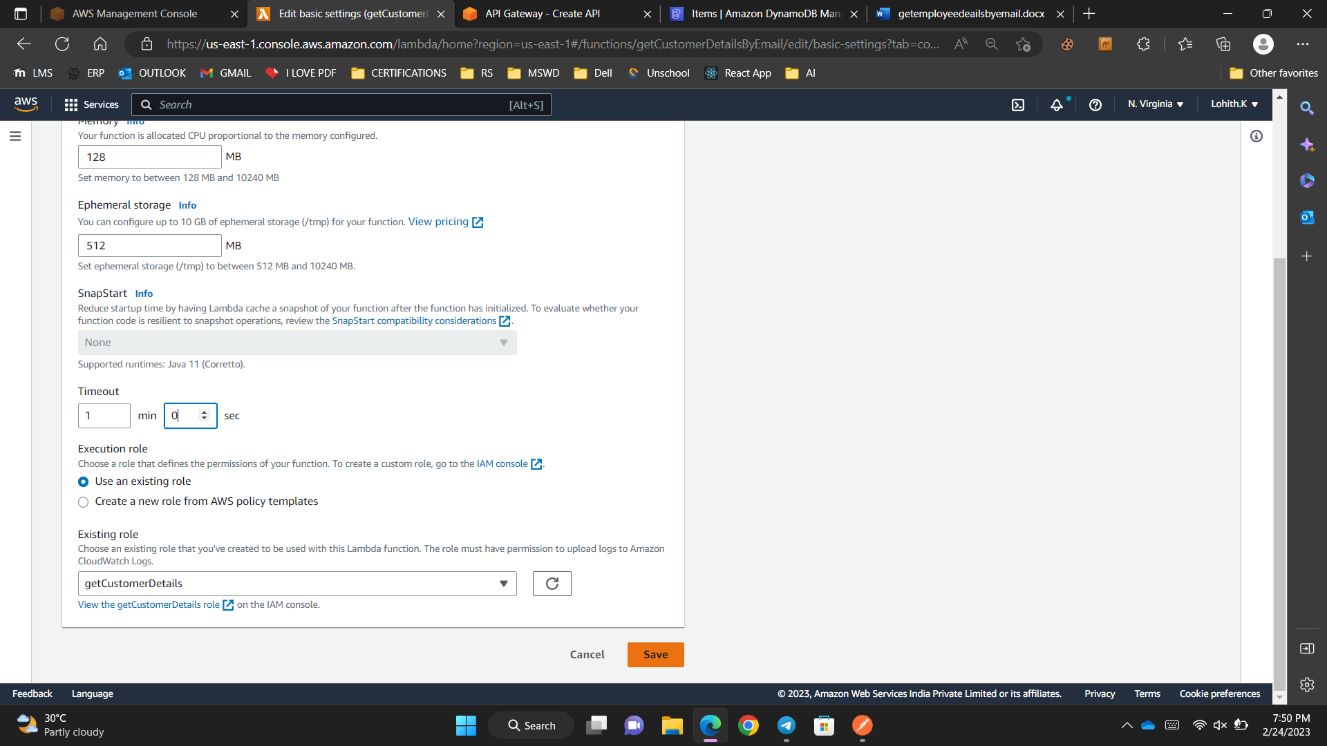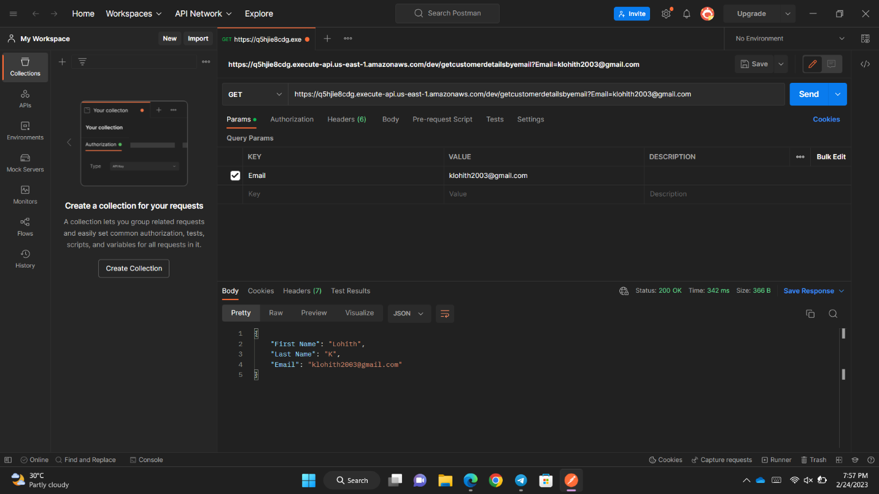

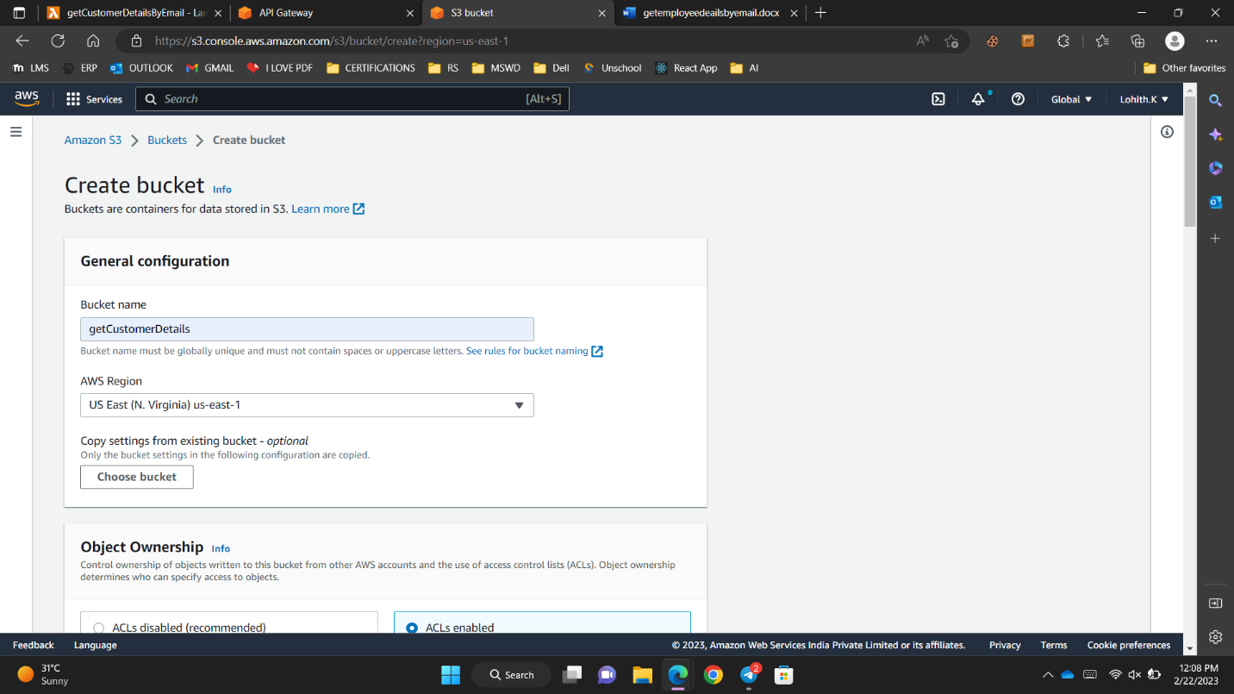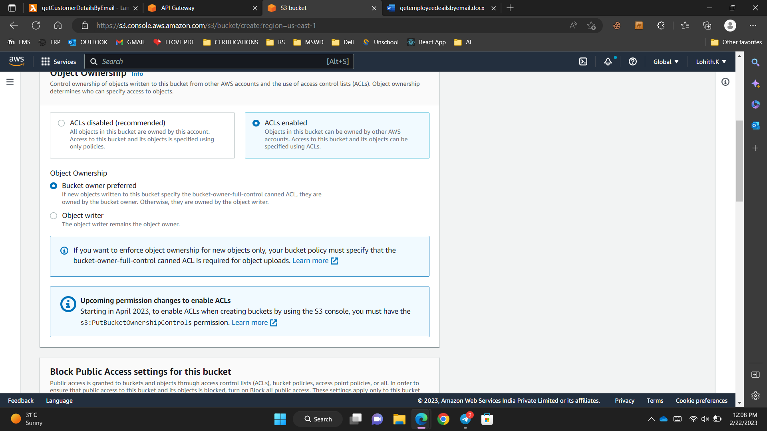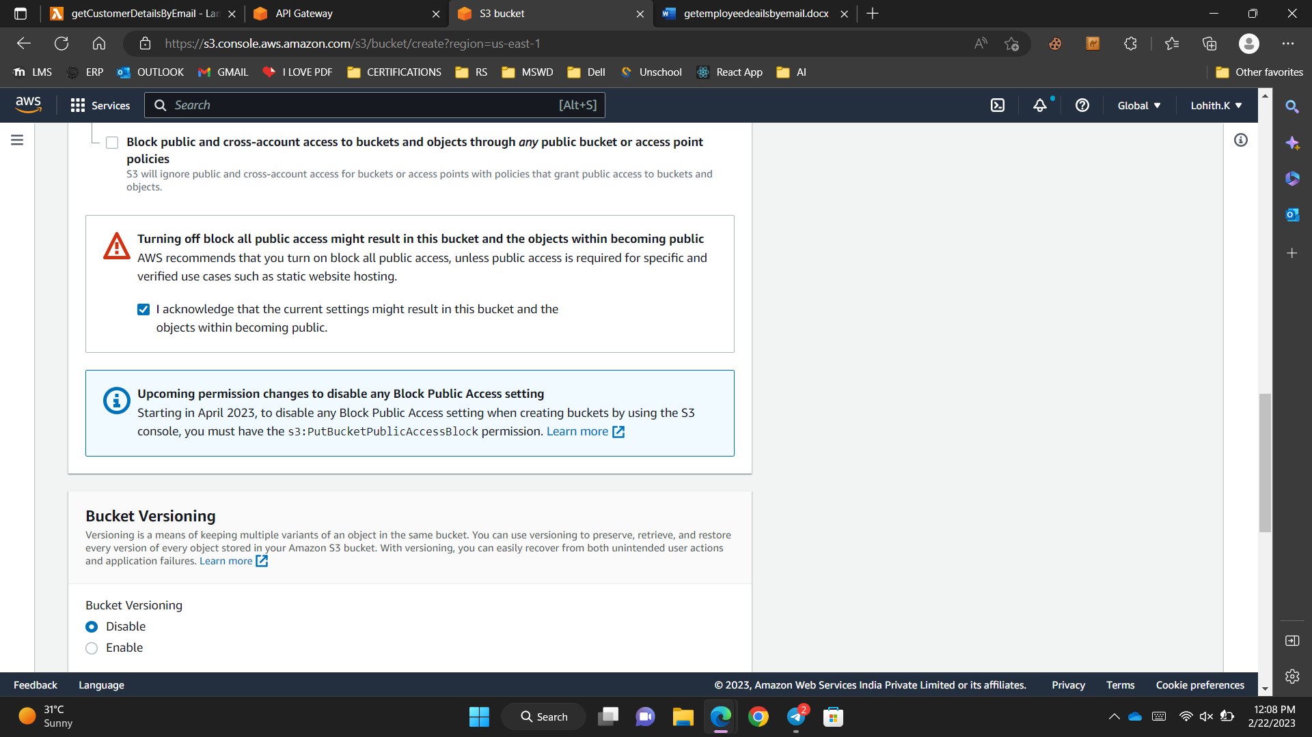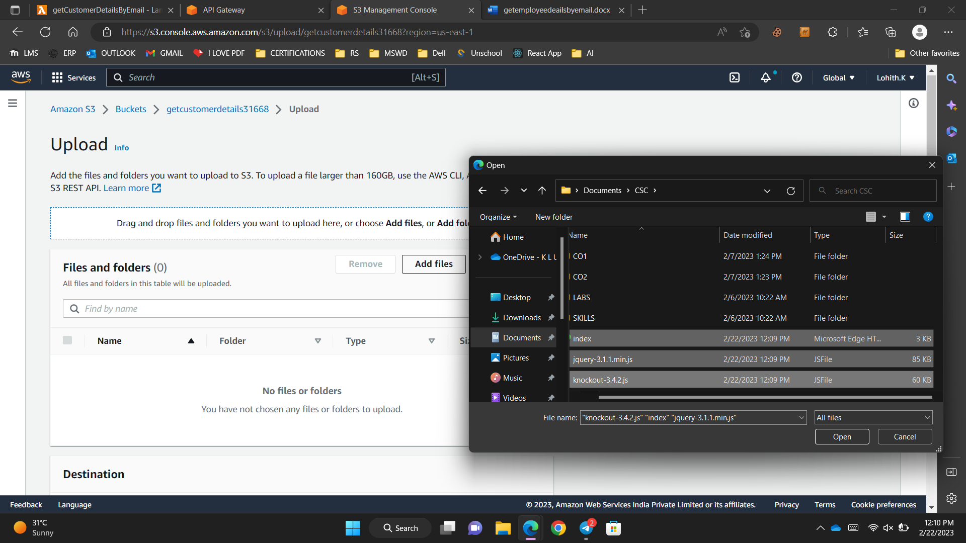

Index.html

<!DOCTYPE html>

<html>

<head>

<title></title>

<meta charset="utf-8" />

<script src="jquery-3.1.1.min.js"></script>

<script src="knockout-3.4.2.js"></script>

<script type="text/javascript">

$(document).ready(function() {

var customerViewModel = function() {

var self = this;

self.firstName = ko.observable("");

self.lastName = ko.observable("");

self.emailId = ko.observable("");

self.searchKey = ko.observable("");

self.getCustomerDetails = function () {

$.ajax({

url: 'https://goxl5wlgoh.execute-api.us-east-1.amazonaws.com/Dev/getcustomerdetailsbyemail',

cache: false,

type: 'GET',

data: { "EmailID": self.searchKey() },

success: function (data) {

self.firstName(data.Item.FirstName)

self.lastName(data.Item.LastName),

self.emailId(data.Item.EmailID)

}

});

}

}

var viewModel = new customerViewModel();

ko.applyBindings(viewModel);

});

</script>

</head>

<body>

<table>

<tr>

<td>Search Key(EmailID):</td>

<td><input type="text" id="txtSearchKey" data-bind="value : searchKey"/></td>

</tr>

</table>

<br />

<table id="CustomerDetails">

<thead>

<tr>

<td>First Name:</td>

<td><label id="firstName" data-bind="text: firstName"/></td>

</tr>

<tr>

<td>Last Name:</td>

<td><label id="lastName" data-bind="text: lastName"/></td>

</tr>

<tr>

<td>EmailID:</td>

<td><label id="emailId" data-bind="text: emailId"/></td>

</tr>

</thead>

</table>

<br />

<table>

<tr>

<td><input type="button" value="GetCustomerDetails" data-bind="click: $root.getCustomerDetails()"/></td>

</tr>

</table>

</body>

</html>

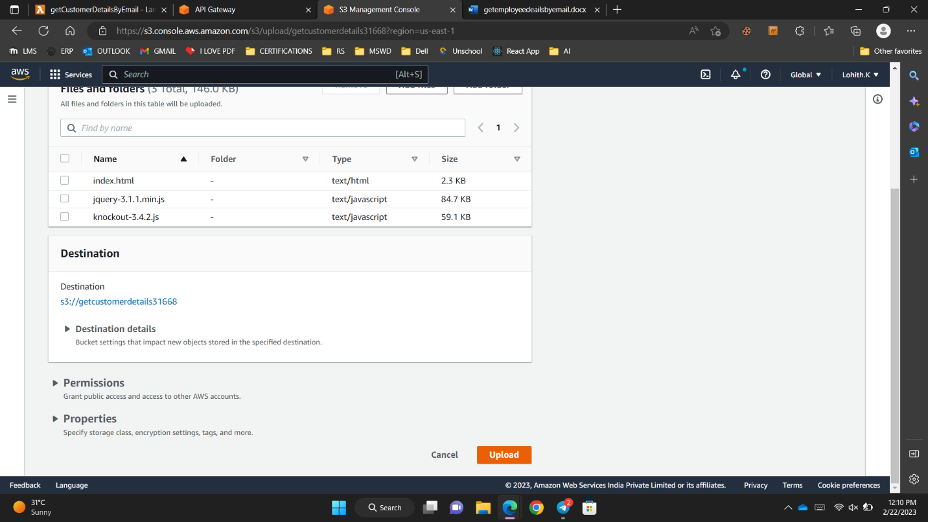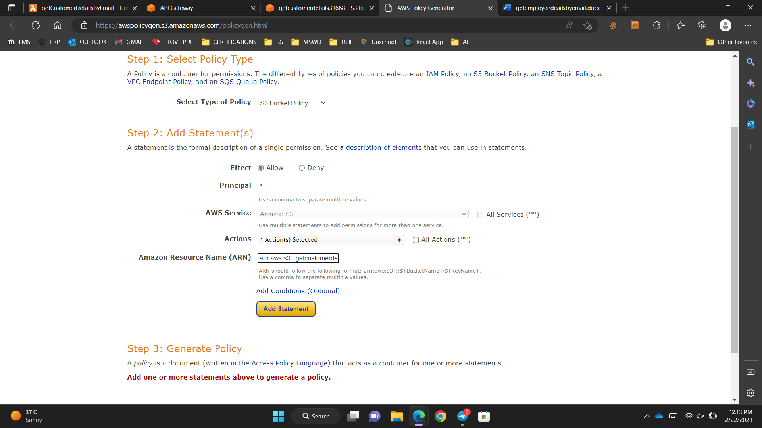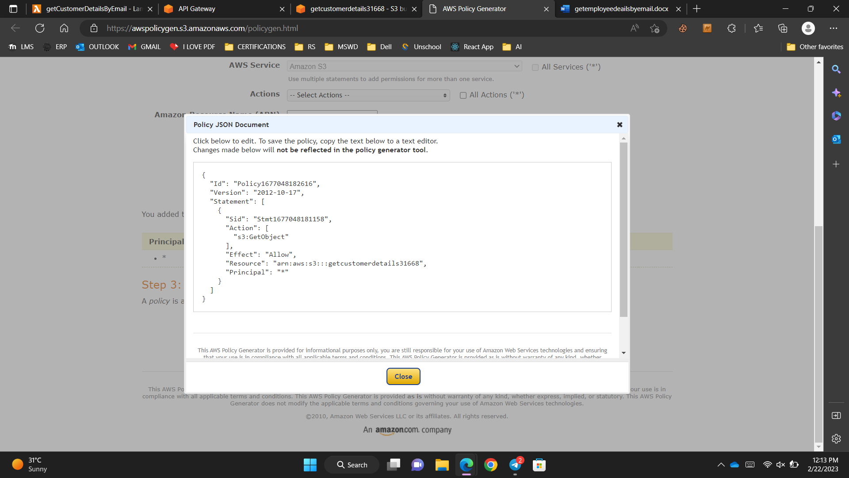

Static web hosting of s3

